Group Contributions Form
Group: GroupNo6
Team Mate  (Name) | Contributions to the Team. | Commendations | Percentage of overall contribution
Edward Hadnett | Created the working prototypes for the 'Stacker' and 'Worm' mini-games. Also the initial prototype of the functioning website, and contributions after Aarju took the lead developer role.  Wrote the User Stories to help plan out the project.  Helped manage the Git/GitHub repository and fixed upload issues so our code didn't break.  Troubleshooting the Node.js backend server and fixing bugs.  Tracked project time and added tasks to Trello when needed. | I want to thank the team for their help on this project. It was a good challenge stepping out of my Cyber Security focus to help with the initial game dev.  I really appreciate Aarju for taking over the programming lead and doing a great job on the frontend and Firebase setup. I also want to thank Marc for keeping the project constantly organized and getting the Ollama AI working. | /100
Marc Jones | Wireframes  Site flow mapping  ‘Jumper’ and ‘Flapper’ mini games  AI integration through Ollama  Question input/output handling  Question JSON editor  Website hosting  Group organisation and planning  Client correspondence  Meeting minute tracking  Project proposal  Client Handbook  Poster | I would like to congratulate and thank my whole team for maintaining open and helpful communication throughout the project.  In particular, Aarju did a great job at creating almost all the frontends of the website. Ranging from designs, site traversal and interaction. Also for handling a lot of the firebase setup and interaction.  I also think Edward did a good job at providing the mini games for the game loop. | ?/100
Aarju Shrestha | Firebase Authentication (Google Sign-In, student/teacher role separation)  Firestore database design and full schema implementation  Session PIN generation and room lookup system  Real-time multiplayer score sync using onSnapshot and increment()  Full frontend: all nine HTML pages, design, responsive layout  localStorage session state management across all pages  Role-based gameplay mechanics  Bug fixes: teacher.html import crash, whitespace trim, Firestore long polling  Final Presentation | I would like to thank the whole team for a great project and a genuinely enjoyable collaboration.  Marc kept the project organised, handled client correspondence, and delivered the AI integration and mini-games, core to the whole game loop.  Edward built the initial website prototype and contributed to the mini-games.  Nicholai's accessibility features, sound design and QA added real polish to the finished product. | ?/100
Nicholai Baes | Capture the flag prototype  Stacker Minigame  Game Assets  Accessibility Features  Visual and Audio assets  Sound Effects  Found space for the project to be ported onto  User Acceptance Testing plan | I want to thank the group for a great academic year and a project to show for it.  Aarju did a great job across the project, especially with the frontend and firebase setup. Marc also did an excellent job integrating AI and creating the minigames. | ?/100
All group members agree to acknowledge the above contributions. (Yes/No)
*We understand that if we answered No to the above, we will be called for a viva with the Module Leader to mediate the dispute. Module Leader will have final decision on the contribution %.

Signatures
Edward Hadnett | 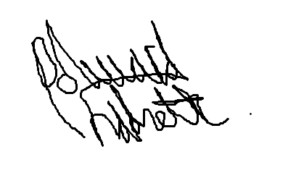
Marc Jones | 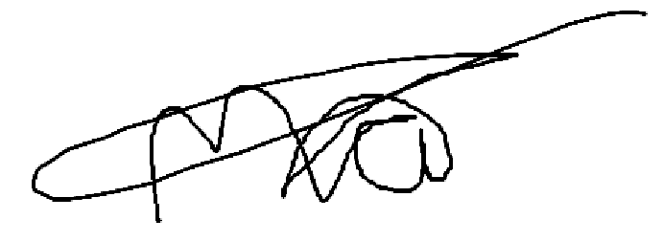
Aarju Shrestha
Nicholai Baes | 

Discuss contributions to analysis, design and documentation, contributions to solution implementation, contributions to LSEP, and any other significant contributions. Below the claim, highlight where in the report/git/Trello/reflection where we can find evidence for the claim.

